INTERIM EVIDENCE REPORT
Colorado Can Protect Every
Healthy and Treatable Shelter Pet
What verified 2024–2025 PACFA data and the financial record show so far
Central finding: Colorado already demonstrates substantial placement capacity. The remaining non-live outcomes are concentrated enough to support targeted action, but the available statewide data cannot yet determine how many involved healthy or treatable animals.

Independent research by Davyd
July 24, 2026 | Colorado

Executive Summary
Colorado’s shelter and rescue system is already operating at a scale that makes universal protection of healthy and treatable pets a credible statewide objective. In 2025, PACFA-licensed organizations reported 162,496 dog and cat intakes and 149,944 live outcomes. They also reported 25,103 dog and cat transfers into Colorado from other states—evidence of a large placement network, though not proof that imported animals displaced local animals.
The remaining non-live outcomes are highly concentrated. Seven economic parents accounted for 9,206—or 74.3%—of the 12,393 statewide dog/cat non-live outcomes reported in 2025. The three largest systems alone accounted for 54.4%. Concentration means statewide improvement does not require every organization to change equally; focused corrective work at a relatively small number of systems can produce disproportionate gains.
The financial record is now substantial but not yet fully comparable. Audits, Form 990 filings, and government budgets establish that major Colorado systems control significant public and private resources. They do not, by themselves, show that a particular death was preventable or that money was misused. Program scope, fiscal periods, enforcement functions, clinics, capital costs, and internal transfers must be aligned before ranking organizations by spending or efficiency.
The most important missing evidence is animal-level outcome classification. PACFA aggregates do not report medical prognosis, individualized behavior and safety findings, owner-request status, custody status, alternatives attempted, or a case-specific reason for each non-live outcome. Until those fields exist, the report can identify the scale and location of the problem—but it cannot honestly calculate the number of healthy and treatable animals lost.
Evidence note: PACFA-2024-IND; PACFA-2025-IND; verified baseline workbook v3.

What This Report Measures
For this research, Colorado’s shelter system means all shelters and rescues licensed by PACFA. Facility reporting rows are consolidated into economic parents where a single nonprofit or government entity operates multiple campuses. The primary objective is not a percentage. It is to protect every healthy and treatable homeless pet entering the system, while reserving euthanasia for otherwise unrelievable suffering and treating grave public-safety decisions as a separate, individualized category.
Important denominator: Live-release rate equals live outcomes divided by final outcomes. It is not live outcomes divided by intake. Statewide totals are organizational transactions, not necessarily unique animals, because transfers within Colorado may cause the same animal to be counted more than once.

Colorado’s Statewide Baseline Is Strong—but Not Complete
The statewide dog/cat live-release rate was 92.75% in 2024 and 92.37% in 2025, a decline of about 0.39 percentage points. The all-species rate moved from 92.63% to 92.31%. These rates describe reported outcomes; they do not determine whether the non-live cases involved irremediable suffering, grave safety risk, treatable conditions, or healthy animals.
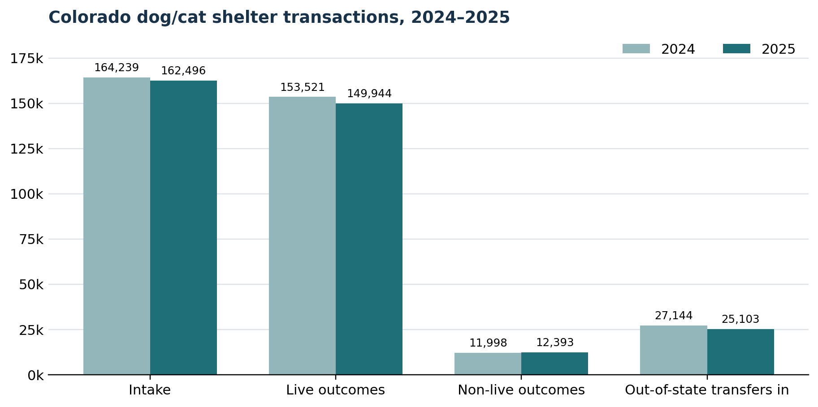
Figure 1. Reported dog/cat transactions. Intake and outcomes are not a unique-animal census.
Year | Intake | Live | Non-live | OOS transfers in | LRR
2024 | 164,239 | 153,521 | 11,998 | 27,144 | 92.75%
2025 | 162,496 | 149,944 | 12,393 | 25,103 | 92.37%
Evidence note: PACFA-2024-IND and PACFA-2025-IND; direct facility-file parse using identical dog/cat formulas.

The Remaining Non-Live Outcomes Are Concentrated
The strongest actionable finding is concentration. HSPPR, Humane Colorado, and Denver Animal Protection reported 6,736 dog/cat non-live outcomes—54.4% of the statewide total. Adding NOCO Humane and Riverdale raises the concentration to 67.2%; adding Foothills and Aurora raises it to 74.3%. Large scale is not itself a failure, but underperformance at scale multiplies the consequences of every program gap.
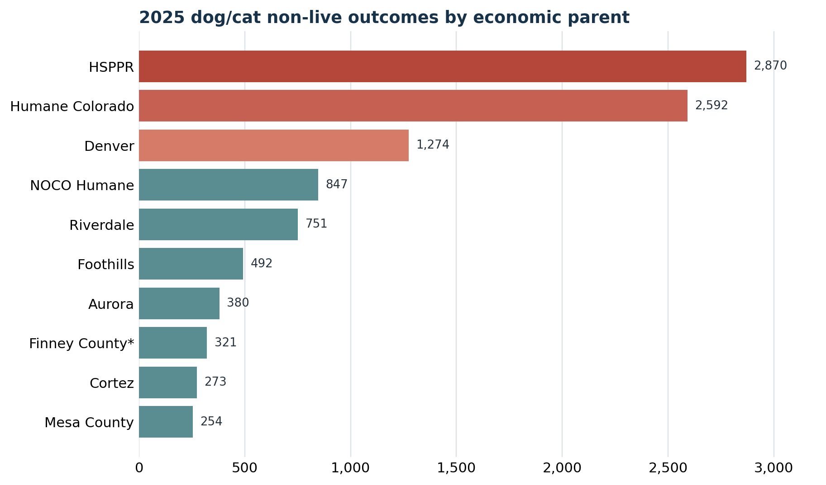
Figure 2. The ten economic parents with the most reported 2025 dog/cat non-live outcomes. *Finney County remains under license-boundary review.
Economic parent | Intake | Non-live | LRR | State share
HSPPR | 24,568 | 2,870 | 88.31% | 23.2%
Humane Colorado | 21,689 | 2,592 | 88.03% | 20.9%
Denver Animal Protection | 7,717 | 1,274 | 83.41% | 10.3%
NOCO Humane | 10,556 | 847 | 91.91% | 6.8%
Riverdale | 7,076 | 751 | 89.29% | 6.1%
Foothills | 7,750 | 492 | 93.71% | 4.0%
Aurora | 3,182 | 380 | 87.98% | 3.1%
Evidence note: PACFA-2025-IND; economic-parent consolidation documented in verified baseline workbook v3.
This table is a screening tool, not a verdict. Open-admission obligations, species and age mix, enforcement duties, legal holds, service areas, condition at intake, and access policies all affect outcomes. Those factors should be tested rather than assumed. The proper response to a large non-live count is a deeper operational and animal-level review—not an unsupported conclusion about motive.

Colorado’s Transfer Network Demonstrates Placement Capacity
Colorado organizations reported 25,103 dog and cat transfers into the state in 2025. That does not prove direct displacement: an imported puppy and a local large adult dog with medical or behavioral needs may require very different adopters, foster homes, and services. It does prove that Colorado has a mature network capable of transporting, fostering, marketing, treating, and placing animals at significant scale.
Share of 2025 import capacity | Equivalent local placements | Imports still possible
5% | 1,255 | 23,848
10% | 2,510 | 22,593
15% | 3,765 | 21,338
20% | 5,021 | 20,082
Evidence note: PACFA-2025-IND. Scenarios are capacity illustrations, not causal estimates.
Interim policy implication: Colorado can adopt a local-first safety protocol for animals facing imminent non-live outcomes without ending interstate rescue. The next analysis must match species, age, size, condition, timing, foster needs, and final outcomes before assigning a precise number of transferable placement slots.

Financial Evidence Shows Scale, Not Cause
The research has now verified audited statements or complete filings for several of Colorado’s largest systems. These records establish organizational scale and the mix of private support, service revenue, government funding, assets, and program spending. They do not yet support a simple statewide ranking because the fiscal periods and program scopes differ.
Economic parent | Period | Revenue | Expense | Scope note
HSPPR | CY 2024 | $22.05m | $23.45m | Shelter + law enforcement; Pueblo included
Humane Colorado | FY 2024 | $19.64m | $35.97m | Shelter, veterinary, equine, education, investigations
NOCO Humane | FY 2025 | $11.53m | $11.00m | Larimer/Weld/Greeley parent; contracts and licensing included
HSBV | CY 2024 | $10.17m | $8.13m | Shelter/behavior/training plus clinic and outreach
Animal Friends Alliance | CY 2025 | $5.82m | $5.17m | Shelter, clinic and related services
Foothills Shelter | CY 2024 | $5.94m | $6.53m | Government shelter; related Friends transfer eliminated
La Plata County HS | CY 2024 | $3.21m | $3.08m | Complete Form 990
Soul Dog Rescue | CY 2024 | $1.86m | $1.60m | Complete Form 990
Evidence note: Audited statements and complete filings listed in Appendix B. Periods and scopes are intentionally retained.
A major consolidation correction is already resolved: Foothills’ government shelter and its Friends fundraising entity cannot simply be added together. The Friends organization transferred $2.179 million to the shelter in 2024; that transfer must be eliminated to avoid double counting. Similar related-entity and campus issues must be resolved before a statewide financial total is published.

Three Municipal Actuals Remain Open
The current public sources provide an adopted budget, amended budget, or projection for Denver, Riverdale, and Aurora—but not a final program actual with complete central-service allocations. Those distinctions are not bookkeeping trivia. Substituting a budget or department-wide total for actual animal-services spending would create a false comparison.
Program | Public figure | Correct label | Still needed
Denver Animal Protection | $7.811m DAP adopted budget; $40.886m DDPHE actual | Program budget / department actual | DAP year-end ledger, internal billing, central-service allocations
Riverdale | $4.730m expense; $1.103m revenue | 2025 amended budget | Final department actual and county indirect-cost schedule
Aurora Animal Services | $2.999m total; $84,634 interfund charges | 2025 projection | Final program actual and allocated-charge workpapers
Evidence note: FIN-DENVER-BUD-2025; FIN-DENVER-ACFR-2025; FIN-RIVERDALE-2026; FIN-AURORA-BUD-2026.

The Central Evidence Gap Is Outcome Classification
The present data can count non-live outcomes but cannot classify their justification. PACFA’s aggregate files do not contain the evidence necessary to separate irremediable suffering, grave public-safety cases, owner-requested end-of-life services, death in care, healthy animals, medically treatable animals, behaviorally treatable animals, and cases that are indeterminate because documentation is inadequate.
Minimum field | Why it matters
Medical prognosis | Distinguishes irremediable suffering from treatable conditions
Behavior/safety assessment | Documents instrument, observations, context, evaluator and reassessment
Owner-request status | Separates owner-directed end-of-life care from shelter decisions
Custody and legal status | Shows which placement options were legally available
Individualized outcome reason | Makes the decision auditable
Alternatives attempted | Records treatment, foster, transfer, rescue, adoption and safety options
Evidence note: Outcome Data Gap sheet, verified baseline workbook v3.
Interpretation rule: The absence or cost of historical records is a transparency limitation. It is not, by itself, proof that a shelter intentionally avoided oversight. Motivation should be described only when documentary evidence supports it.

Interim Recommendations
- Create statewide decision-level outcome reporting. Require structured medical prognosis, behavior/safety findings, owner-request status, custody status, individualized reason, decision date, reviewer, and alternatives attempted for every non-live outcome.
- Establish a local-at-risk placement protocol. Before an animal faces a non-live outcome, provide timely statewide rescue and foster notice and give qualified partners meaningful time and complete records to respond.
- Target corrective work where the outcomes are concentrated. Begin with the economic parents responsible for most non-live outcomes, while controlling for intake duties, species, age, legal holds, geography, and condition at intake.
- Measure program scale, not program existence. Report the number and share of eligible animals receiving foster pleas, rescue notice, medical or behavioral treatment, proactive reunification, adoption marketing, and retention assistance.
- Modernize municipal contracts. Tie public funding to transparent intake access, reunification, rescue cooperation, treatment, foster utilization, live outcomes, data quality, and corrective plans—not merely custody and volume.
- Complete the municipal financial record. Obtain Denver, Riverdale, and Aurora final program actuals, internal billings, indirect-cost schedules, and central-service allocations before publishing cost comparisons.
- Preserve interstate rescue while reserving capacity for Colorado animals. Use matched species-, age-, size-, condition-, and timing-based analysis to identify the modest share of existing placement capacity needed for local animals facing death.
- Create an annual independent accountability cycle. Publish formulas, denominators, source documents, missing-data flags, and supported corrections; give featured organizations a fair opportunity to respond with records.

Further Questions
- What proportion of 2025 non-live outcomes involved confirmed irremediable suffering, grave safety risk, owner-requested end-of-life services, treatable conditions, or healthy animals?
- Which organizations import the most animals, and how do species, age, size, condition, foster type, timing, and final outcomes compare with local at-risk animals?
- How long do residents wait to surrender or bring in found animals, and how many animals are refused, diverted, abandoned, or kept outside the measured system?
- Which rescue, foster, adoption, reunification, treatment, retention, volunteer, and community-cat programs operate at the scale of need?
- What do municipal contracts require, reward, measure, and fail to measure?
- Which Colorado facilities are true peers after controlling for mission, intake responsibility, species and age mix, legal holds, geography, and service population?

Caveats and Assumptions
Transactions are not unique animals. Transfers within Colorado can produce more than one intake and outcome for the same animal.
Non-live is not synonymous with preventable loss. The aggregate data do not establish health, treatability, suffering, public-safety risk, or owner-request status.
A 90% rate is only a diagnostic floor. It is neither the objective nor evidence that every healthy and treatable pet was protected.
Transfer volume demonstrates capacity, not displacement. A causal claim requires matching animal characteristics, timing, foster needs and placement outcomes.
Financial scale does not establish misuse or causation. Periods, campuses, clinics, enforcement, education, capital, restrictions, and related entities must be aligned.
Historical license records are identity evidence only. The July 2019 roster does not establish an organization’s calendar-year 2025 PACFA status.
Missing records remain missing. The report does not treat absent disposition data or unavailable municipal allocation schedules as zero.

Appendix A — Method and Definitions
Item | Working rule
System boundary | All shelters and rescues licensed by Colorado PACFA
Unit of analysis | Facility reporting row and consolidated economic parent; not necessarily a unique animal
Live outcomes | Adoption, return to owner, transfer, and other documented outcomes in which the animal remains alive
Non-live outcomes | Death in care, killing/euthanasia, and missing/stolen/unaccounted-for status; categories should remain separate when available
Final outcomes | Live plus non-live dispositions; excludes animals still in inventory
Live-release rate | Live outcomes ÷ final outcomes
Healthy | No medical or behavioral condition requiring rehabilitation before placement
Treatable | Condition can be cured, controlled, managed, rehabilitated, or accommodated with reasonable care and support
Primary objective | Protect every healthy and treatable homeless pet entering the PACFA-licensed system
Evidence note: Scope & Definitions sheet and controlling project handoff, Revision 2.

Appendix B — Selected Source Register
PACFA-2024-IND: 2024 Colorado Animal Shelter and Rescue Individual Report.xlsx
PACFA-2025-IND: 2025 Colorado Animal Shelter and Rescue Individual Statistics dataset
FIN-HSPPR-AUD-2024: HSPPR 2024 audited financial statements
FIN-HC-AUD-2024: Humane Colorado / Denver Dumb Friends League FY2024 audited statements
FIN-NOCO-AUD-2025: NOCO Humane FY2025 audited statements
FIN-FOOTHILLS-AUD-2024: Foothills Animal Shelter 2024 financial statements
FIN-DENVER-BUD-2025: City and County of Denver Final 2025 Budget
FIN-DENVER-ACFR-2025: City and County of Denver 2025 ACFR
FIN-DENVER-DETAIL-2025: Transparent Denver detailed expenditures
FIN-RIVERDALE-2026: Adams County 2026 budget / Riverdale 2025 amended table
FIN-AURORA-BUD-2026: Aurora 2026 adopted budget / Animal Services 2025 projection
FIN-HSBV-AUD-2024: Humane Society of Boulder Valley 2024 audited statements
FIN-AFA-AUD-2025: Animal Friends Alliance 2025 audit
FIN-LAPLA-990-2024: La Plata County Humane Society complete 2024 Form 990
FIN-SOULDOG-990-2024: Soul Dog Rescue complete 2024 Form 990

